**19.3.1**

**Do you know how much food is here?**

A lots. **We can't cook this much food before it goes bad**

Can we move this boxes? **There isn't much room to walk in here**

Uhm. There isn't easy time. We are opening 5 minutes for lunch

**How much time does it take to move boxes?**

**This many boxes? A lot of time**

OK. **We can do it after lunch but before dinner. There are many customer then**

Ok, we can do it then

I have to open the restaurant now

What's wrong?

There are no customers

O o. We need customer to eat all of this food

We can email our friend and ask them to come here for lunch

That's a good idea

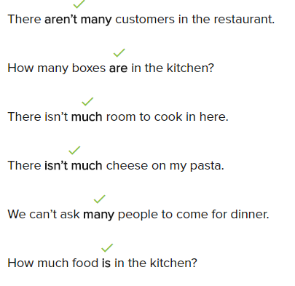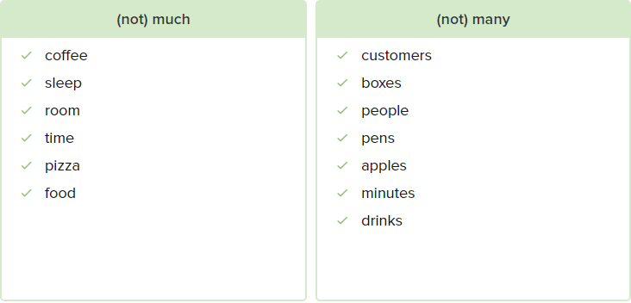

**Conversation**

What do you want to make for dinner?

I don’t know. There isn’t my food here

We can make pizza?

OK. But there isn’t much meat

We can use vegetables. We have onion

OK. How many onion do we want to use?

Let’s use one onion, and we have green pepper

Great! I love green pepper. Let’s use many pepper on the pizza

OK. Do we have tomato sauce?

There isn’t much tomato sauce, but we have some

We can use that and add a little water to it. Let’s put cheese on the pizza

Good idea. Uh oh. There isn’t much cheese

We need more cheese. Why don’t we go out for pizza?

OK. But we don’t have much time. The pizza place closes in 30 minutes!

**Exercise**

**There aren’t many** restaurants in this town - just a few uptown

We can’t move this **many** boxes before we open

**How much** time do yo need to make dinner?

**We don’t need many** eggs, only one or two

How many boxes are in the kitchen?

-> **A lot of** boxes

**How many** tomatoes do we need for the pasta sauce?

-> Six

**How much is** the milk?

--> Three dollars

How much juice do we have?

--> **There isn’t much**, but we have some

**When** does the store open?

It’s 7:50, and the movie starts at 8:00!

--> Let’s go! We don’t have much time

**19.3.2**

Now to write the email:

**Dear friends**! **How are you? Are you hungry? Please come to the restaurant today for lunch**. I’m making lunch. **We have a lot of food that we need to cook**. **See you soon. Sofi**

Is this OK?

**Dear friends! Come to the restaurant for delicious lunch**. **Our cook, Sofi makes great food.** Free coffee with lunch. **Best. Diego**

That’s a good email

Sent

Can you get people free coffee?

Don’t tell Nadi

OK. Now! Alway

Sofi! Start making food now!

How much food?

A lots

Why our many customer? There aren’t many empty tables

That’s because there are many customer. Now start cooking

Why does Sofi write an email to her friends?

--> She wants them to eat the food at the restaurant

Diego says people can have free coffee at the restaurant

Diego doesn’t want Nadi to know about the free coffee

Why does Sofi make a lot of food?

---> Because there are a lot of customers

